PERSONAL INFORMATION | Tran Thanh Trung
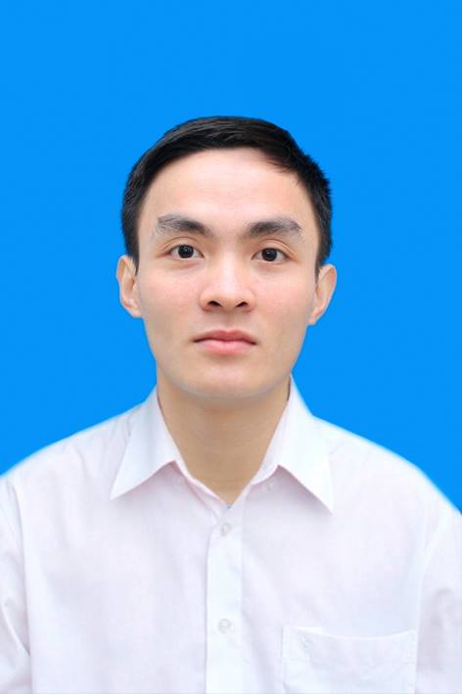 |   Huong Gia, Phu Cuong, Soc Son, Ha Noi
 |  01686639018

Trungtranthanh.k56@gmail.com
 | Sex Male | Date of birth 21/12/1993

POsition | Fresher, Junior.

EDUCATION AND TRAINING

2011-2015 | Studen at Ha Noi University of Sicence  Mathematic Informatics and Mechanic

CAREER OBJECTIVE

Good developer
Software Architect
Full stack developer

TAKEN PROJECTS AND EXPERIENCE

2014  2015 | Website about Hotel booking using PHP  Website about service provider using Java

JOB REQUIREMENT

Have knowledge PHP , Java.
Familiar with AngularJs,Bootstrap.
Familiar Webservice, Maven, Spring.
Understand OOP, Data Structures and Algorithms .

PERSONAL SKILLS

Mother tongue(s) | Vietnamese
Other language | UNDERSTANDING |  | SPEAKING |  | WRITING
Other language | Listening | Reading | Spoken interaction | Spoken production
English | B1 | B1 | B1 | B1 | B1
Can read English documents and basic communication.

